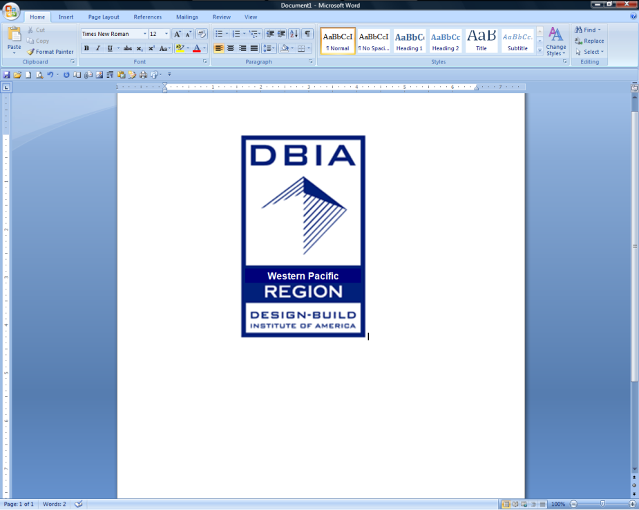**DBIA WESTERN PACIFIC REGION**

**College Scholarship Application**

Application Deadline: ***April 15, 2013***

**TERMS, CONDITIONS AND ELIGIBILITY CRITERIA**

**Purpose:** The scholarship is designed to recognize and encourage excellence in the Design-Build approach to Design and Construction. The scholarship is awarded based on merit/academic achievement, demonstrated interest in & understanding of the Design-Build methodology, leadership skills, and financial need. Awards to be made on May 6, 2013 and winners will be invited to attend the DBIA Western Pacific Awards banquet on May 23, 2013. **Please submit questions to:** [dboughner@pankow.com](mailto:dboughner@pankow.com)

**Scholarships Available:** Plus the cost of travel and lodging to attend award ceremony.

* (8) Eight $5,000.00 DBIA Western Pacific Region Scholarships

**Required Application Documentation**

* Application Form
* Written Endorsement from Professor, Industry Professional or DBIA Member.
* Written Essay (3-Pages Maximum, 12 point font, 1.5 lines spacing, Times New Roman). Topic: How would you explain (or sell) the idea of using DB to a private sector Owner? Essay should incorporate: (1) A demonstrated interest in Design-Build (2) A passion for collaboration and innovation (3) How all members of the DB team (builders, designers, owners) work together in taking a project from creative design to constructed reality.
* Resume
* Short Autobiography (500 words maximum) including how you plan to use your DB education in your future endeavors.
* Submit **one** Electronic file containing all required documentation in PDF format, not to exceed 7-MB.

**Required Documentation (Scholarship Winners only)**

* Transcripts (in PDF format only, NO links to other sources)
* Proof of Tuition

**College/Enrollment Status**

* Candidates must be enrolled in a trade school, community **c**ollege or university in the Western Pacific Region of the U.S. (Arizona, California, Hawaii, or Nevada). Graduate students are welcome to apply.

**Academic Requirements**

* Student in good standing making reasonable progress towards a degree in Design and/or Construction.
* 2.5 minimum cumulative G.P.A. (through latest grading period).
* Construction Management, Civil Engineering, Mechanical Engineering, Electrical Engineering, Architectural Engineering, Architecture, Landscape Architect, Interior Design, or other major pertinent to Design and Construction.
* Demonstrated interest in Design-Build through internship, project work, or participation in DBIA Student Chapter.
* We highly encourage all Applicants to be a student member of DBIA (Local student chapter or DBIA student member).If you are not already a member, or need assistance on becoming a member, please visit the DBIA website at: <http://www.dbia.org/membership/individual/>
* Leadership positions/activities on campus and/or community service activities, particularly those that relate to design and construction, to be considered.

**Financial Need**

* Financial need will be a criterion considered.

**Terms**

* Scholarship Recipients to receive funds in 2 equal installments: 1st half at the beginning of the school year (September 2013) and the second half at the end of the school year (May 2014).
* Scholarship Award will be paid directly to the student.

**DBIA WESTERN PACIFIC REGION**

**College Scholarship Application**

Application Deadline: *April 15, 2013*

**Applicant:**

1. Please read terms, conditions and requirements from page 1 before completing application form.

2. Complete Section 1 below and sign where indicated.

3. Email application and required documentation in **one** PDF file (7-MB Max) to Debbie Boughner at [dboughner@pankow.com](mailto:dboughner@pankow.com)

4. **Submit all questions by 4/1/13** to: [dboughner@pankow.com](mailto:dboughner@pankow.com)

**(Section 1: To Be Completed By Applicant)**

**Student’s Name: Last First Middle Home Phone Number**

### 

**Mailing Address: Number/Street City State Zip Code Email Address**

**Name of College / University Campus City/State Grade Level**

**Major (if “Other” Major, identify Major here) Status GPA**

**List below all scholarships, grants or other form of tuition aid or assistance that you currently receive and include dollar amounts**

**List below all construction industry related organizations, highlight DBIA related Organizations, student chapters, community service or groups where you have actively participated and describe your participation. (Also attach your resume)**

**x**

**Applicant: Please do not write below this line.**

**(Section 2: To Be Completed By Scholarship Committee)**

**Date Received: Tuition Amount: $ GPA**

**Eligibility Confirmation: Qualifying School & Major Essay Received Resume**

**Letter of Recommendation Autobiography Transcripts (Scholarship Winners only)**

**Proof of Tuition (Scholarship Winners only)**