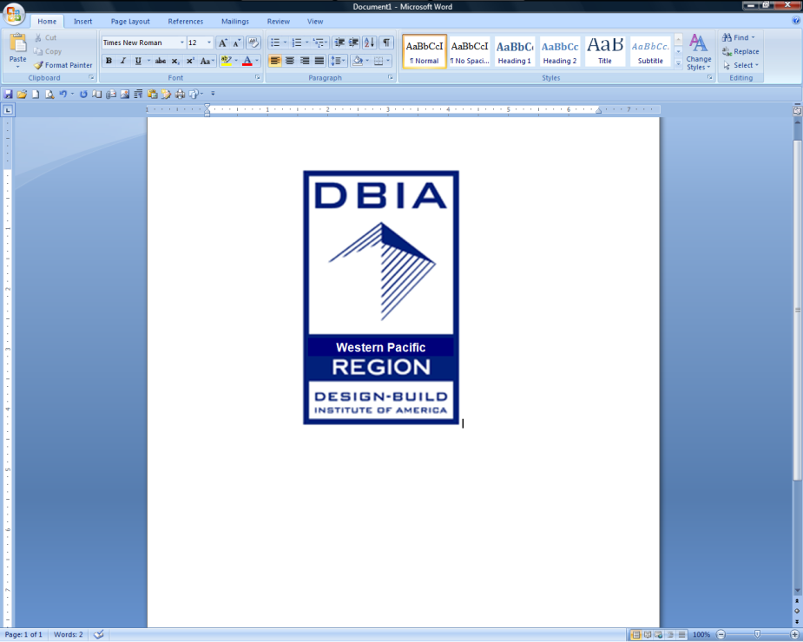**DBIA WESTERN PACIFIC REGION**

**College Scholarship Application**

Application Deadline: *April 13, 2012*

**TERMS, CONDITIONS AND ELIGIBILITY CRITERIA**

PURPOSE: The scholarship is designed to recognize and encourage excellence in the Design-Build approach to Design and Construction. The scholarship is awarded based on merit/academic achievement, demonstrated interest in & understanding of the Design-Build methodology, leadership skills, and financial need. Awards to be made on May 2, 2012 and winners will be invited to attend the DBIA Western Pacific Awards banquet on May 24, 2012.

**Scholarships Available:** Plus the cost of travel and lodging to attend award ceremony.

* (2) Two $5,000.00 Mike Joki gkkworks Scholarships
* (4) Four $5,000.00 DBIA Western Pacific Region Scholarships

**Required Application Documentation**

* Application Form
* Written Endorsement from Professor, Industry Professional or DBIA Member.
* Written Essay (3-Pages Maximum, 12 point font, 1.5 lines spacing, Times New Roman). Topic: As stated on the DBIA website **“**The Design-Build Institute of America is the only organization that defines, teaches and promotes best practices in Design-Build. Design-build is an integrated approach that delivers design and construction services under one contract with a single point of responsibility. Owners select design-build to achieve best value while meeting schedule, cost and quality goals.”  Why do you believe that design-build achieves best value for Owners? Essay should show demonstrated interest in and understanding of the Design Build methodology and leadership skills.
* Resume and Transcripts.
* Short Autobiography (500 words maximum) including how you plan to use your DB education in your future endeavors.
* Proof of Tuition

**College/Enrollment Status**

* Candidates must be enrolled in a trade school, community college or university in the Western Pacific Region of the U.S. (Arizona, California, Hawaii, or Nevada).

**Academic Requirements**

* Student in good standing making reasonable progress towards a degree in Design and/or Construction.
* 2.5 minimum cumulative G.P.A. (through latest grading period).
* Construction Management, Civil Engineering, Mechanical Engineering, Electrical Engineering, Architecture, or other major pertinent to Design and Construction.
* Demonstrated interest in Design-Build through internship, project work, or participation in DBIA Student Chapter.
* It is preferred that Applicants be a student member of DBIA (Local student chapter or DBIA student member).

**Leadership/Community**

* Leadership positions/activities on campus and/or community service activities, particularly those that relate to design and construction, to be considered. If established, should be a member of the DBIA Student Chapter.

**Financial Need**

* Financial need will be a criterion considered.
* Provide proof of Tuition, plus disclosure of other Scholarships and Grants.

**Terms**

* Scholarship Recipients to receive funds in 2 equal installments: 1st half at the beginning of the school year (September 2012) and the second half at the end of the school year (May 2013).
* Scholarship Award will be paid directly to the student.

**DBIA WESTERN PACIFIC REGION**

**College Scholarship Application**

Application Deadline: *April 13, 2012*

**Applicant:**

1. Please read terms, conditions and requirements from page 1 before completing application form.

2. Complete Section 1 below and sign where indicated.

3. Email application and required documentation in PDF to Gloria Moore at [gmoore@dbiawpr.org](mailto:gmoore@dbiawpr.org)

**(Section 1: To Be Completed By Applicant)**

**Student’s Name: Last First Middle Home Phone Number**

### 

**Mailing Address: Number/Street City State Zip Code Email Address**

**Name of College / University Campus City/State Grade Level**

**Major (if “Other” Major, identify Major here) Status GPA**

**List below all scholarships, grants or other form of tuition aid or assistance that you currently receive and include dollar amounts**

**List below all construction industry related organizations, highlight DBIA related Organizations, student chapters, community service or groups where you have actively participated and describe your participation. (Also attach your resume)**

**Short autobiography (500 words maximum) include: How you plan to use your DB education in your future endeavors.**

**Applicant Signature Date**

**Applicant: Please do not write below this line.**

**(Section 2: To Be Completed By Scholarship Committee)**

**Date Received:** **Tuition Amount: $****GPA**

**Eligibility Confirmation:  Qualifying School & Major**  **Essay Received  Transcripts**

**Proof of Tuition**  **Letter of Recommendation  Autobiography  Resume**